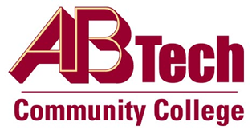

# Asheville-Buncombe Technical Community College (A-B Tech) Policy Manual

## Policy 1010: College Credentials

It is the policy of the Board of Trustees that no one shall ever share their authenticators, or the access to College information and assets that authenticators provide, under any circumstance. Should access to College information and/or assets be required by any volunteer, vendor, contractor, partner or liaison, IT will assist with the set-up and maintenance, per standard operating procedures, after approval by the Vice President of Operations/Chief Information Officer. Violations will be dealt with to the fullest extent of the law.

## Scope

This policy applies to all A-B Tech employees, students, volunteers, vendors, contractors, partners, and liaisons.

## Definitions

Authenticator: The means used to confirm the identity of a user, including, but not limited to passwords, biometrics, ID cards, etc.

## References

Reviewed by the Executive Leadership Team, November 13, 2019

Reviewed by the College Attorney on November 25, 2019

## Policy Owner

Vice President of Operations/CIO, Ext. 7900

Approved by the Board of Trustees on December 2, 2019